**DBMS (ORACLE ACADEMY)**

**ASSIGNMENT - 01**

**TRAFFIC FLOW MANAGEMENT**

**INTRODUCTION:**

**Traffic Flow Management Systems (TFMS)** are designed to enhance the efficiency of transportation networks in urban areas. These systems utilize real-time data from various sources, such as sensors and cameras, combined with historical traffic patterns, to optimize traffic routes, manage intersections, and control traffic signals. The primary goals of a TFMS include reducing congestion, improving safety, and minimizing travel times.

**Task 1: Entity Identification and Attributes**

**Entities and Attributes:**

1. **Roads**
   * RoadID (PK)
   * RoadName
   * Length (in meters)
   * SpeedLimit (in km/h)
2. **Intersections**
   * IntersectionID (PK)
   * IntersectionName
   * Latitude
   * Longitude
3. **Traffic Signals**
   * SignalID (PK)
   * SignalStatus (Green, Yellow, Red)
   * Timer (countdown to next change)
   * IntersectionID (FK) - references IntersectionID in Intersections
4. **Traffic Data**
   * TrafficDataID (PK)
   * Timestamp
   * Speed (average speed on the road)
   * CongestionLevel
   * RoadID (FK) - references RoadID in Roads

**Task 2: Relationship Modeling**

**Relationships:**

1. **Roads to Intersections**
   * Relationship: Roads connect to Intersections
   * Cardinality: One-to-Many (One road can connect to multiple intersections)
   * Optionality: Mandatory (A road must connect to at least one intersection)
2. **Intersections to Traffic Signals**
   * Relationship: Intersections host Traffic Signals
   * Cardinality: One-to-Many (One intersection can have multiple traffic signals)
   * Optionality: Optional (An intersection may not have traffic signals)
3. **Roads to Traffic Data**
   * Relationship: Roads have Traffic Data
   * Cardinality: One-to-Many (One road can have multiple traffic data entries)
   * Optionality: Mandatory (Traffic data must be associated with a road)

### Task 3: ER Diagram Design

**ER Diagram:**

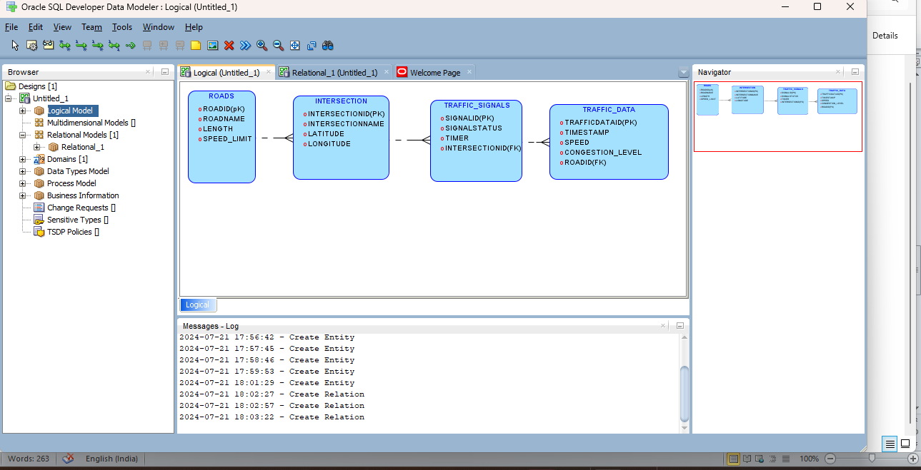

**Task 4: Justification and Normalization**

**Justification of Design Choices:**

1. **Scalability:**
   * The design is modular, allowing for easy addition of new roads, intersections, and traffic signals without altering existing structures.
   * Real-time traffic data can be continuously added, supporting scalability in data volume.
2. **Real-Time Data Processing:**
   * The Traffic Data entity is designed to handle real-time updates with a Timestamp attribute, enabling real-time traffic management and historical analysis.
3. **Efficient Traffic Management:**
   * The relationships between Roads, Intersections, and Traffic Signals allow for effective route optimization and adaptive traffic signal control.

**Normalization Considerations:**

1. **First Normal Form (1NF):**
   * All attributes are atomic, ensuring no repeating groups or arrays within an entity.
2. **Second Normal Form (2NF):**
   * All non-key attributes are fully functionally dependent on the primary key. For example, in the Traffic Data entity, Speed and CongestionLevel depend on TrafficDataID.
3. **Third Normal Form (3NF):**
   * No transitive dependencies exist. Each non-key attribute is only dependent on the primary key, ensuring data integrity and minimizing redundancy.

**Deliverables**

1. **ER Diagram:**
   * A well-drawn ER diagram reflecting the structure and relationships of the TFMS database as illustrated above.
2. **Entity Definitions:**
   * Clearly defined entities and attributes supporting the ER diagram.
3. **Relationship Descriptions:**
   * Detailed descriptions of relationships with cardinality and optionality constraints as outlined above.
4. **Justification Document:**
   * Explanation of design choices, normalization considerations, and how the ER diagram supports TFMS functionalities.

**Summary**

**Conceptual Understanding:**

* The TFMS ER diagram accurately models the key entities and relationships needed to manage and optimize traffic flow in a city, integrating real-time and historical traffic data.

**Technical Accuracy:**

* The entities and attributes are correctly defined, and the relationships are accurately modeled with appropriate cardinality and optionality constraints.

**Documentation and Clarity:**

* Clear documentation of entities, attributes, and relationships ensures that the ER diagram is understandable and maintainable.

**Design and Solution Justification:**

* The design choices are well-justified, with considerations for scalability, real-time data processing, and adherence to normalization principles ensuring data integrity and efficiency.